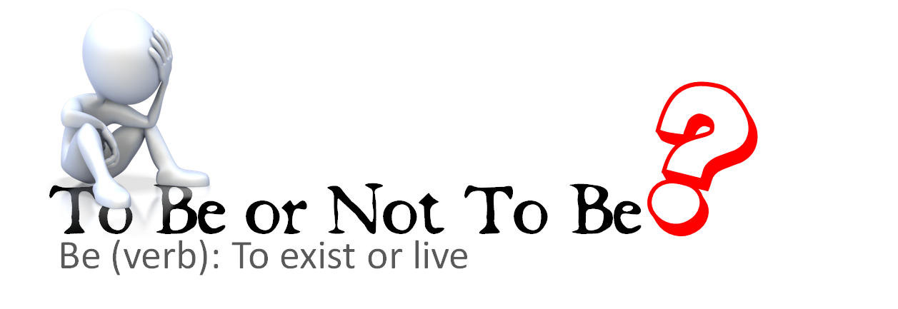
Re-Read the Text. Think. Talk. React.
- Draw boxes to chunk the text, grouping lines that go together.
- Re-read each chunk. Stop. Talk about it with your group.
  - Define unfamiliar words. Try dictionary.com.
  - Try to paraphrase (put into your own words) the text to understand what it is saying.
  - What is the meaning?
  - How did Shakespeare convey that meaning?
    - Figurative language (metaphors, similes, personification)
    - Words with powerful connotations
- React to the text.
  - Make connections (to personal experiences, to other texts, to current events or big ideas).
  - Ask questions.
  - Agree or disagree.
- Record your reactions.
  - Complete the graphic organizer below as you go to capture your analysis.
  - Annotate the text. Feel free to underline, highlight, circle, doodle in the margins on the text. The boxes may not be enough room!
Text Chunk | Words | Language | Meaning | Reactions
1  “To be…end them?” | be
2  “No more..to be wish’d.” | consummation
3  “To sleep…so long life.” | rub (the noun)  calamity
4  “For who would bear…bare bodkin?” | contumely  insolence  merit  quietus  bodkin
5  “To grunt and sweat…know not of?” | fardels  bourn
6  “Thus conscience...name of action.” | hue  pith  awry

